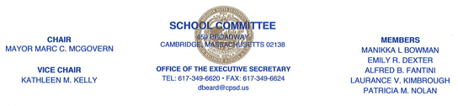

May 28, 2019

N O T I C E

There will be a meeting of the Community Relations Sub-Committee on Tuesday, September 24, 2019 at 6:00 p.m., in the School Committee Conference Room, Cambridge Rindge and Latin School, 459 Broadway, Cambridge, the purpose is to continue discussion of Controlled Choice, School Committee outreach to school communities any other business to come before the Sub-Committee. It is anticipated that this meeting will end by or before 8:00 p.m.

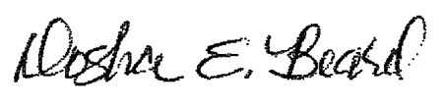
Dosha E. Beard
Executive Secretary to the School Committee

c: School Committee Members
Superintendent
Administration
City Clerk
Principals
Family Liaisons
Student Representatives, CRLS

Posted on 9/24/19 at 9:15 A.M.

